Documentation case – AIS
Instructions:
See the narrative below which represents the process and controls of Leopards, Inc. Please perform the following:
1) Prepare a flowchart for the Purchasing and Disbursements cycle. Use your Warren Sports reference materials for the manual symbols and also see below for additional symbols that may best represent the ‘system’ or electronic aspects of the flowchart (such as database files, input devices and information flow). If you want to use your own symbols, please use a key to show me what you are depicting.
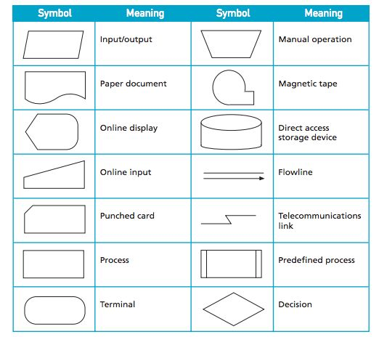
(Punched card and Magnetic tape would likely not apply to this case.)
Also, use on-page and off-page connectors where appropriate (see Warren Sports reference and examples). A spreadsheet will suffice and it has all the symbols above in its “Shapes” section of “Insert”.

2) On your flowchart, identify the key “what can go wrong” risks relative to errors and fraud in financial reporting. Create a tickmark to place in the area of the flowchart where the risk would occur and explain it in a tickmark legend. You don’t need to identify every risk, just the major or key risks.

3) In a different worksheet of your spreadsheet, create a matrix that maps the process to the risk (what can go wrong) to the desired control and document whether the control exists and is effective. Don’t forget to analyze segregation of duties as well.

Leopards, Inc. (The Company) – Purchasing and Disbursements Narrative
The Company has established an approved vendor list which is managed by the controller. Other individuals can review the list, but only the controller can add to or change the list. Before a vendor is added, the controller checks with the Chief Operating Officer to ensure the products to be purchased will meet the Company's specifications.
Oracle is the Company’s enterprise resource planning software and a Supply/Demand report is run periodically. This report contains information regarding customer demand and current inventory levels. Based on the report, logistics determines raw material ordering requirements. When raw materials are needed, logistics enters a requisition and electronically sends the requisition to the plant manager for approval (based on the incoming order and the inventory levels on hand to fulfill that order). The plant manager's approval is indicated via electronic signature and the purchase requisition is sent back to logistics.
To generate the purchase order, logistics sends the approved requisitionto purchasing and purchasing electronically submits the purchase order to the vendor. Purchase orders are generated by the Oracle system in a pre-numbered, sequential order. Only the purchasing departments can generate purchase orders.
Once a purchase order is electronically sent to the vendors, the Oracle system automatically records the purchase order in the subsystem. Outstanding purchase orders are tracked via the system. A report of open purchase orders is reviewed weekly by the purchasing manager to investigate any overdue purchase orders.
The receiving process is initiated when the inventory arrives at the warehouse dock via trucks. Only the receiving department has the authority to receive inventory. All incoming inventory is segregated and counted/inspected by the receiver. Once the preliminary count and inspection is complete the items are accepted and the items are unloaded and moved to raw materials storage.
Once the receiving of goods is accepted, the packing slip included with the delivery is compared by the receiver to the actual amount received to ensure accuracy. The purchase order is reviewed in the Oracle system and the amount ordered is compared to the amount received. If there is no discrepancy, the receiving department records the receiving information intoa form in the Oracle System and stamps the packing slip. The stamp consists of a date, receiving number, and signature blank. The packing slip is sent to purchasing which then signs the packing slip to indicate approval. If a discrepancy exists the problem is documented and the logistics department is notified. The receiving numbers are in sequential order throughout the Company. The receiving department bundles all packing slips processed during the day to the accounts payable department each night.
The checks are printed through the Oracle system. The Oracle check writing function is interfaced with the A/P subsystem, therefore, when the checks are printed the A/P subsystem is automatically updated, (i.e. – the amounts paid are taken out of the A/P subsystem).

The recording process is initiated when A/P receives an invoice from a vendor. Each invoice is stamped with the date on which it is received. Invoices are matched to the receiving documents by A/P clerks that they have received from the warehouse based on PO numbers. A/P clerks match both the receiving documents and vendor invoices to each other and to the POs in the system. If there is a quantity discrepancy between the receiving report and invoice, a proof of delivery is obtained from the vendor and the proper correction is made in the Oracle system. If there is a price discrepancy between the invoice and the PO, logistics and purchasing is notified and the discrepancy is investigated. If there are any such discrepancies, A/P documents the process performed to clear the discrepancy and this documentation is attached to the invoice and receiving document. Once the invoice, PO and receiving documents are matched, the invoice information is entered (recorded) in the Oracle A/P system. Only the A/P department and the controller have access to the Oracle A/P system.
The A/P subsystem and general ledger are both kept within Oracle, therefore the general ledger is automatically updated when invoices are entered into the A/P system. A manual total of the invoices entered and an Oracle generated batch are run weekly by the A/P clerks to ensure that all invoices entered were the system. Any discrepancies between the reports are investigated and corrected by A/P clerks.
The Company cuts checks once a week, on Thursday. Special, one-off, checks require approval of the controller. The controller, A/P manager and A/P clerks are the only employees authorized to print checks. Blank checks are maintained in a locked file cabinet, which only the AP department can access. A preliminary check register is printed and reviewed by the controller and the treasurer. A final check register is then printed and approved by the treasurerwho compares the checks to the invoices to ensure all checks and invoices match correctly. After the checks are printed and signed by the treasurer, A/P clerks match the invoice, check copy, and receiving report and files this information. The controller reconciles the payables bank account monthly. This reconciliation is reviewed by the A/P manager and reconciling items are documented and investigated by the A/P manager. The A/P manager reconciles vendor statements to the A/P accounts monthly and resolves differences.
After the check run, a total A/P journal is generated and printed through Oracle and it is compared to the previous A/P journal to ensure that the difference is the amount on the check run. The controller periodically reviews the A/P subsystem and investigates payable items due over 60 days old.
The controller reviews the vendor list monthly.

